**Experiment 1 : Make the LED glow and fade using Arduino UNO**

**Aim:** The principal aim of this experiment is to interface a LED with the microcontroller and to Make LED glow using Arduino Uno.

**1.COMPONENTS REQUIRED**

1. Arduino UNO
2. Breadboard
3. Jumper wires
4. 100 Ohm resistors

a. ARDUINO UNO:

Arduino UNO is a microcontroller board based on the ATmega328P. It has 14 digital input/output pins (of which 6 can be used as PWM outputs), 6 analog inputs, a 16 MHz ceramic resonator, a USB connection, a power jack, an ICSP header and a reset button. It contains everything needed to support the microcontroller; simply connect it to a computer with a USB cable or power it with a AC-to-DC adapter or battery to get started. You can tinker with your UNO without worrying too much about doing something wrong, worst case scenario you can replace the chip for a few dollars and start over again.

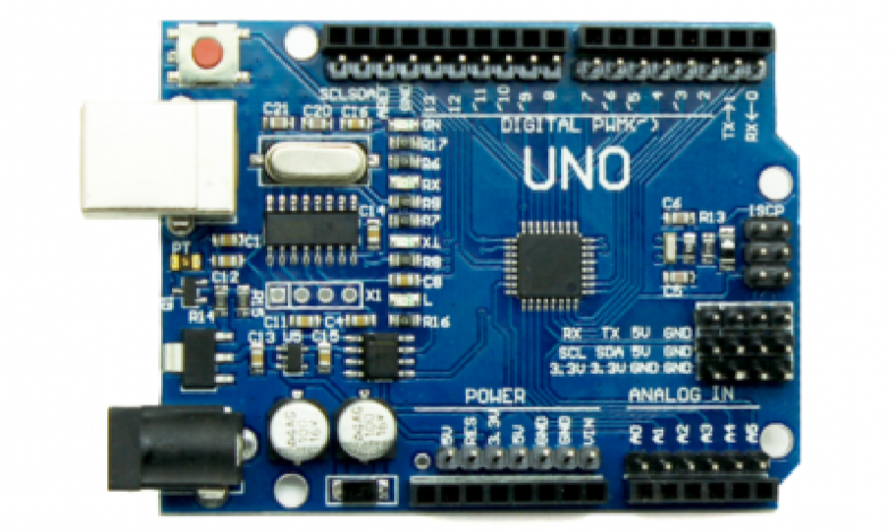

Figure 1.0 - Arduino UNO

b. BREADBOARD:

Breadboards are one of the most fundamental pieces when learning how to build circuits. Breadboards are commonly utilized while prototyping temporary circuits. It is useful to designers because it allows components to be removed and replaced easily.

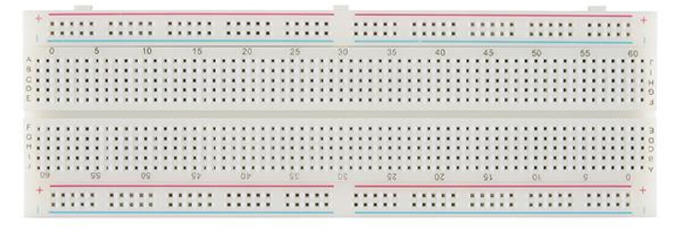

Figure 1.1 – Breadboard

**2.SOFTWARE**

Software is a generic term to refer to the scripts and programs that run on a microprocessor or microcontroller and execute specific tasks.

2.1 GET START WITH ARDUINO IDE

Follow the steps to install Arduino IDE:

Step 1: Browse for the URL - ' https://www.arduino.cc/en/software '

Step 2: In DOWNLOAD OPTIONS, choose Windows/Linux/Mac OS accordingly.

Step 3: Select - JUST DOWNLOAD. The download will start!

Step 4: Run the downloaded setup file.

**3. PROGRAM to implement Blinking LED Using Arduino**

void setup() {

pinMode(13,OUTPUT);

}

void loop() {

digitalWrite(13,HIGH);

delay(1000);

digitalWrite(13,LOW);

delay(500);

}

4. Results

**Blinking LED Using Arduino is successfully implemented**